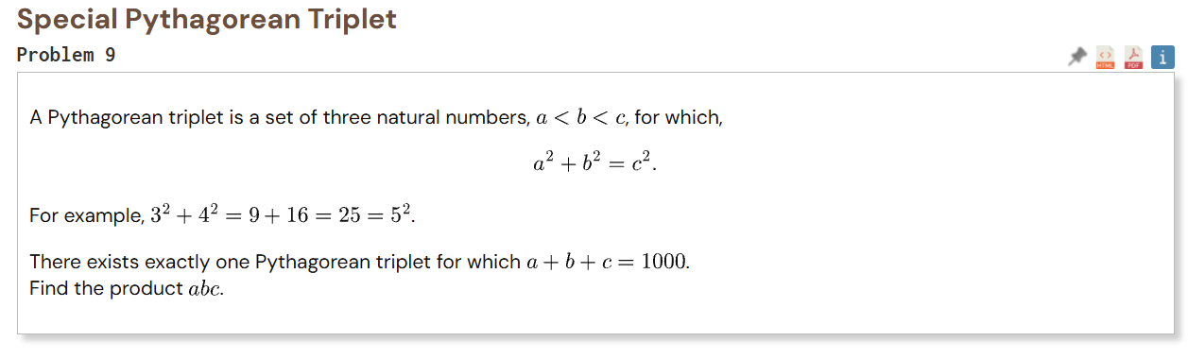
Sometimes, it happens that the algorithm is not helpful at all. Other times, a code, an algorithm, and a computer will be of use. It is with no doubt that this question taught me patience and variable substitution to reach a particular goal. In fact, substituting variables make the mathematics easier.

From Euclid’s Formula for Pythagorean triplets: the positive integers n and m, with $0< n<m$ , forms triplets of the form
$$a=m^{2}-n^{2}$$
$$b=2mn$$
$$c=m^{2}+n^{2}$$
Utilizing the perimetric condition, $a+b+c=1000$, the following formula is obtained: $\left(m^{2}+n^{2}\right)+2mn+m^{2}-n^{2}=1000$ $→$ $m(m+n)$ = 500.
From here, I learned two valuable things:
- Constraints lead to solutions
- Substitute variables to make the math easier.
Let $k=m+n, since m×k=500,$$$this means that \left(m, k\right) should be factors of 500.$$
For the constraints, m > n and k > m to be respected the only pair of numbers is (20, 25), $which later yields an n=5.$
Substituting, $a=375, b=200, c=425$. And their sum yields 1000!

